REVERSE ENGINEERING – ACTIVITY REPORT
Product: Logitech M331 Silent Plus Wireless Mouse

PART I – STUDYING THE PRODUCT

1. External Features

Physical Construct
- Shape: Asymmetric, contoured right-hand body, approx. 106 × 68 × 39 mm.
- Top: Single moulded button cover with left and right buttons, divided by the scroll-wheel slot; rubber scroll wheel in the centre.
- Sides: Rubber side grips for a secure, comfortable hold.
- Bottom: ON/OFF slide switch, optical sensor window, low-friction feet, and a removable battery door covering the AA battery tube and the USB receiver storage.
- Accessory: USB nano receiver (2.4 GHz) that plugs into the computer.
- Assembly: Plastic parts held by snap hooks plus only two screws (one hidden under the label in the battery well).
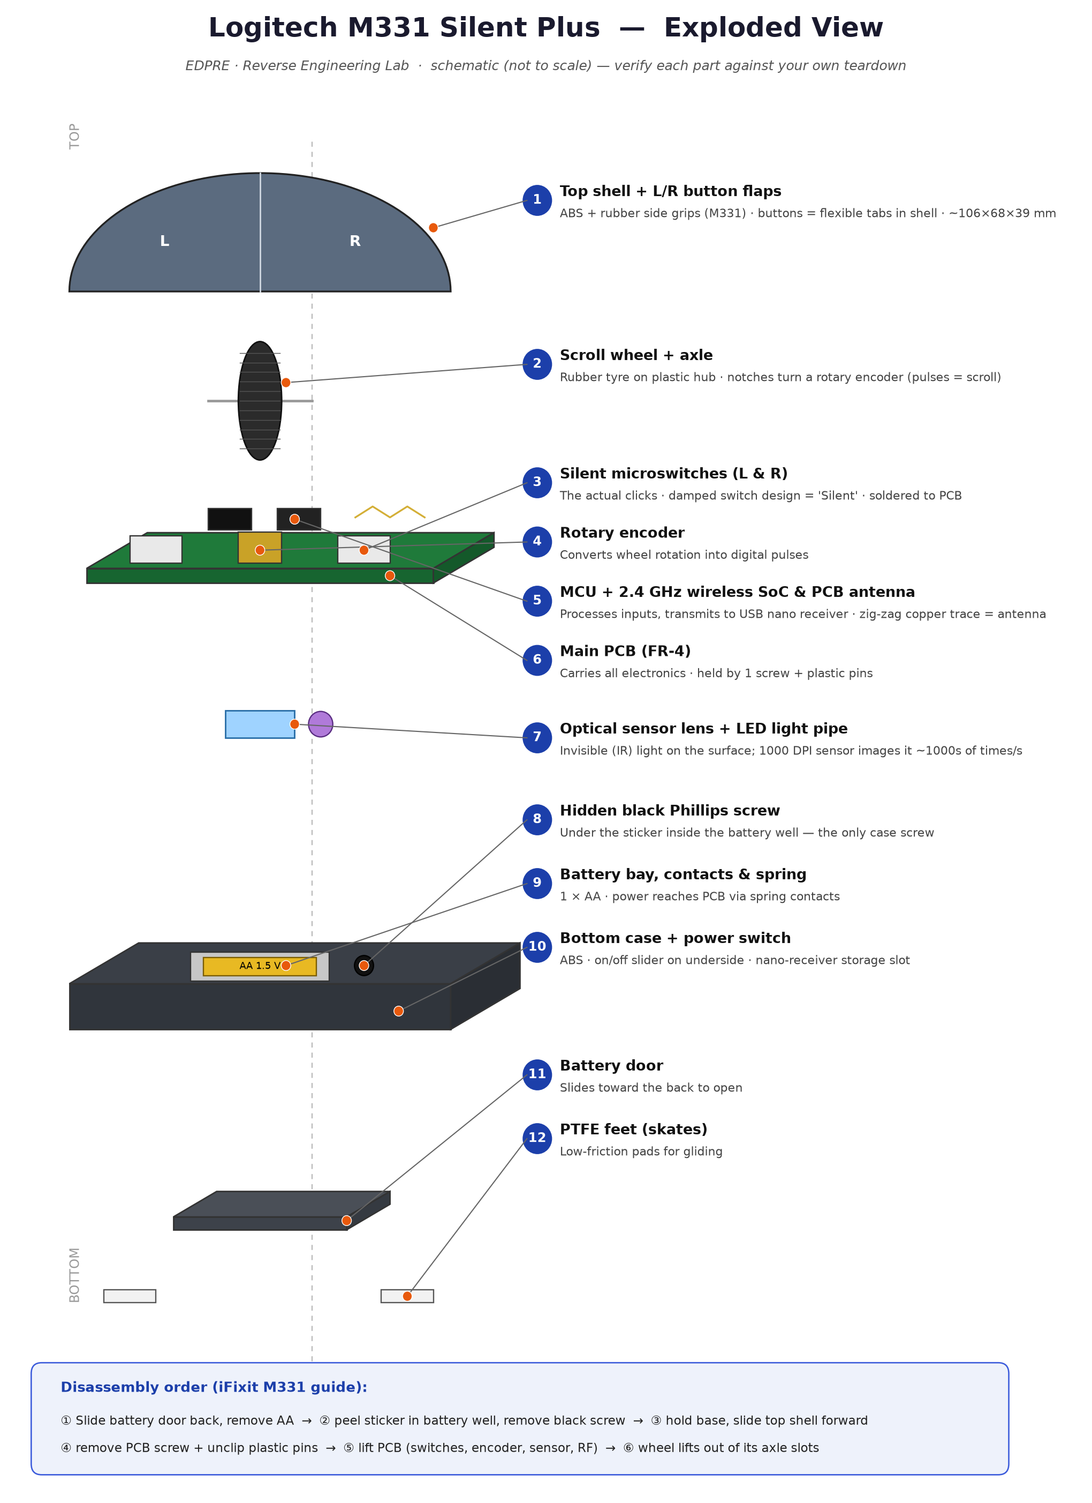
Fig. A – Exploded view of the M331 (schematic).

Subsystems Used
- Power subsystem
- Optical tracking subsystem
- Input subsystem (buttons and scroll wheel)
- Processing & wireless communication subsystem
- Mechanical / enclosure subsystem

Description of Subsystems
- Power: one 1.5 V AA battery, spring contacts, ON/OFF switch and a regulator circuit supply all electronics.
- Optical tracking: an infrared LED, lens and image sensor detect how far and in which direction the mouse moves.
- Input: silent left/right switches, a wheel-click switch and a scroll-wheel encoder capture user commands.
- Processing & wireless: a microcontroller with a 2.4 GHz radio collects all inputs and transmits them to the USB receiver.
- Mechanical: the housing, grips, feet and battery door protect the parts and give comfort.
(Detailed explanation of each subsystem is given in Part III, Section 4.)

Modes of Operation
- OFF mode: slide switch OFF — no power is drawn (used for travel/storage).
- Active mode: sensor tracks movement continuously; clicks and scrolls are sent to the computer.
- Idle / sleep mode: after a period of no use, the electronics enter low-power sleep to save battery.
- Wake-up: movement or a click wakes the mouse instantly and it reconnects to the receiver.

2. Purpose of the Product
The M331 is a wireless pointing device used to control the on-screen cursor, select and open items, and scroll through content — with the specific purpose of doing this quietly, so it can be used in shared or quiet spaces without click noise.

3. User Needs Addressed
User need | How the M331 addresses it
Quiet working (libraries, offices, at night) | Silent switches reduce click noise by over 90%
Freedom from cables | 2.4 GHz wireless with USB receiver, up to 10 m range
Low maintenance | Up to 18 months on one AA battery; no cleaning (optical)
Comfort over long use | Contoured right-hand shape and rubber grips
Portability | Compact size; receiver can be stored inside; ON/OFF switch
Ease of use | Plug-and-play on Windows, macOS, Linux — no driver needed
Affordability and reliability | Budget price; no moving tracking parts to wear out

PART II – PRODUCT ORIGIN TO LATEST INVENTIONS

1. Difference in Technology Across Versions
The computer mouse has evolved from a wooden mechanical prototype to today's high-precision wireless optical devices. Each stage solved the main drawback of the previous one.

1.1 Early Stage (1964–1968): Mechanical wheel mouse
- Origin: Invented by Douglas Engelbart with engineer Bill English at the Stanford Research Institute (1964); publicly shown in the 1968 'Mother of All Demos'; patented in 1970 as an 'X-Y position indicator'.
- Technology: A wooden box with two perpendicular metal wheels; each wheel turned a potentiometer to measure X and Y motion. One button.
- Improvement: First practical pointing device — direct on-screen selection instead of typed commands.
- Drawbacks: Bulky, wired, could only roll smoothly along one axis at a time, needed a lot of desk space.

1.2 First Generation (1972 – late 1990s): Ball (opto-mechanical) mouse
- Technology: Bill English (Xerox PARC, 1972) replaced the wheels with a rubber ball. The ball turns two rollers (X and Y); each roller spins a slotted disc between an LED and a photo-detector, producing pulses. Used on the Xerox Alto/Star and popularised by the Apple Lisa (1983) and Macintosh (1984).
- Improvement: Smooth motion in any direction, cheap to manufacture, became the standard PC input device.
- Drawbacks: Dust and dirt collected on the ball and rollers (needed regular cleaning), required a mouse pad, low resolution, mechanical wear.

1.3 Second Generation (1995 – early 2000s): Scroll wheel and LED optical mouse
- Technology: The scroll wheel was added in the mid-1990s (e.g., Microsoft IntelliMouse, 1996). From 1999, LED optical mice (e.g., Microsoft IntelliMouse Explorer) used a tiny camera sensor that photographs the surface thousands of times per second and compares images to detect movement.
- Improvement: No moving tracking parts → no cleaning, much higher precision and reliability, works on most surfaces without a pad.
- Drawbacks: Poor tracking on glass or glossy surfaces; still wired.

1.4 Third Generation (2000s): Wireless and laser mice
- Technology: Early cordless mice used infrared/RF; 2.4 GHz radio with small USB receivers became standard. Laser sensors (e.g., Logitech MX1000, 2004) gave higher resolution and worked on more surfaces. Logitech's Unifying receiver (2009) let one receiver serve several devices.
- Improvement: Freedom from cables, longer range, better tracking.
- Drawbacks: Batteries needed; early wireless had lag and interference.

1.5 Latest Generation (2010s – present): Smart, efficient and ergonomic mice
- Technology: Very-high-DPI sensors (tens of thousands of DPI in gaming mice), tracking on glass (Logitech Darkfield), low-latency wireless, Bluetooth multi-device use, rechargeable USB-C batteries, ultra-low-power chips giving 1–2 years on one AA cell, silent switches (the M330/M331 Silent Plus, 2016), ergonomic and vertical designs.
- Improvement: Long battery life, quiet operation, comfort, multi-device productivity.
- Drawbacks: Higher cost for premium models; more electronic waste from batteries and non-repairable designs.

2. Current Status – Core Smart Technologies Used in the Product (M331)
Technology | What it does in the M331
Optical tracking (invisible IR light) | 1000 DPI optical sensor; no visible glow; reliable on most desk surfaces
2.4 GHz wireless + USB nano receiver | Plug-and-play connection, range up to 10 m (Logitech spec)
SilentTouch switch technology | Reduces click noise by over 90% (Logitech spec) while keeping the same click feel
Ultra-low-power electronics | Up to 18 months on one AA battery (Logitech spec); auto-sleep when idle + ON/OFF switch
Ergonomic design | Contoured right-hand shape with rubber side grips; rubber scroll wheel
Cross-platform HID | Works on Windows, macOS, Linux without special drivers

3. Engineering Importance of This Evolution
- Mechanical → optical → electronic: moving parts were replaced by sensors and chips, giving higher reliability and precision.
- Integration (VLSI): the optical sensor is a CMOS image sensor with an on-chip DSP, and the MCU + radio are combined in one SoC — many functions on one chip lowers cost, size and power.
- Low-power design: efficient chips and sleep modes stretch one AA cell to over a year.
- Wireless communication: 2.4 GHz digital radio links replaced cables.
- Human factors: ergonomics and noise reduction show engineering for the user, not just function.
- Design for manufacturing: snap-fit housings and very few screws (only two in the M331) reduce assembly cost.

PART III – INTERNAL COMPONENTS & WORKING FLOW

1. Introduction of the Product
The Logitech M331 Silent Plus (released 2016; sold as the M330 in some regions) is a right-handed wireless optical mouse with silent clicks. It has three inputs (left click, right click, scroll wheel with wheel-click), runs on one AA battery and connects to a computer through a 2.4 GHz USB nano receiver. Approximate size: 106 × 68 × 39 mm.

2. Photographs of the Internal Components
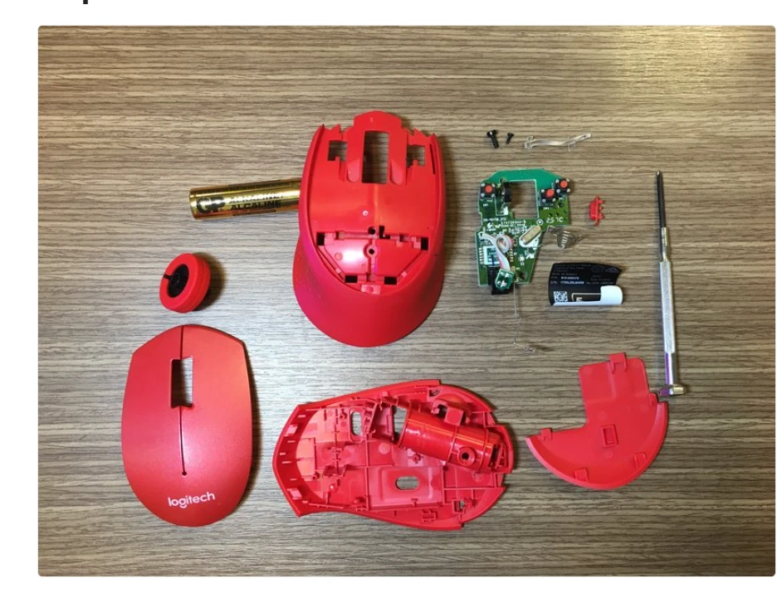
Fig. 1 – Fully disassembled M331: top button cover, upper shell, base with battery tube, battery door, scroll wheel, PCB, lens, screws, spring, label.
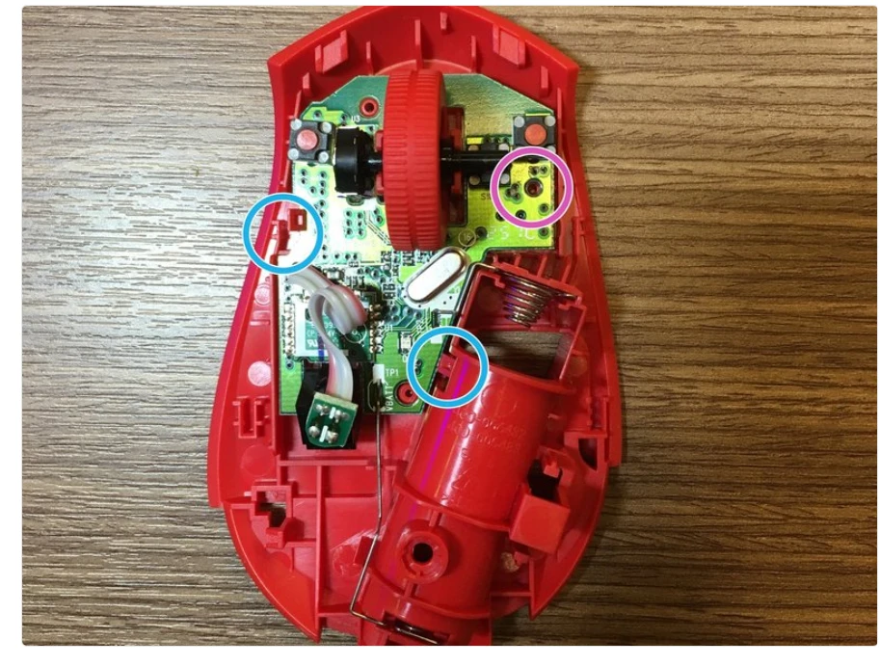
Fig. 2 – Main PCB inside the base: L/R silent switches, scroll wheel and encoder, crystal oscillator, wiring, battery tube and spring.
Photo source: iFixit, 'Logitech M331 Disassembly' guide (CC BY-NC-SA).

3. Internal Block Diagram (Functional View)
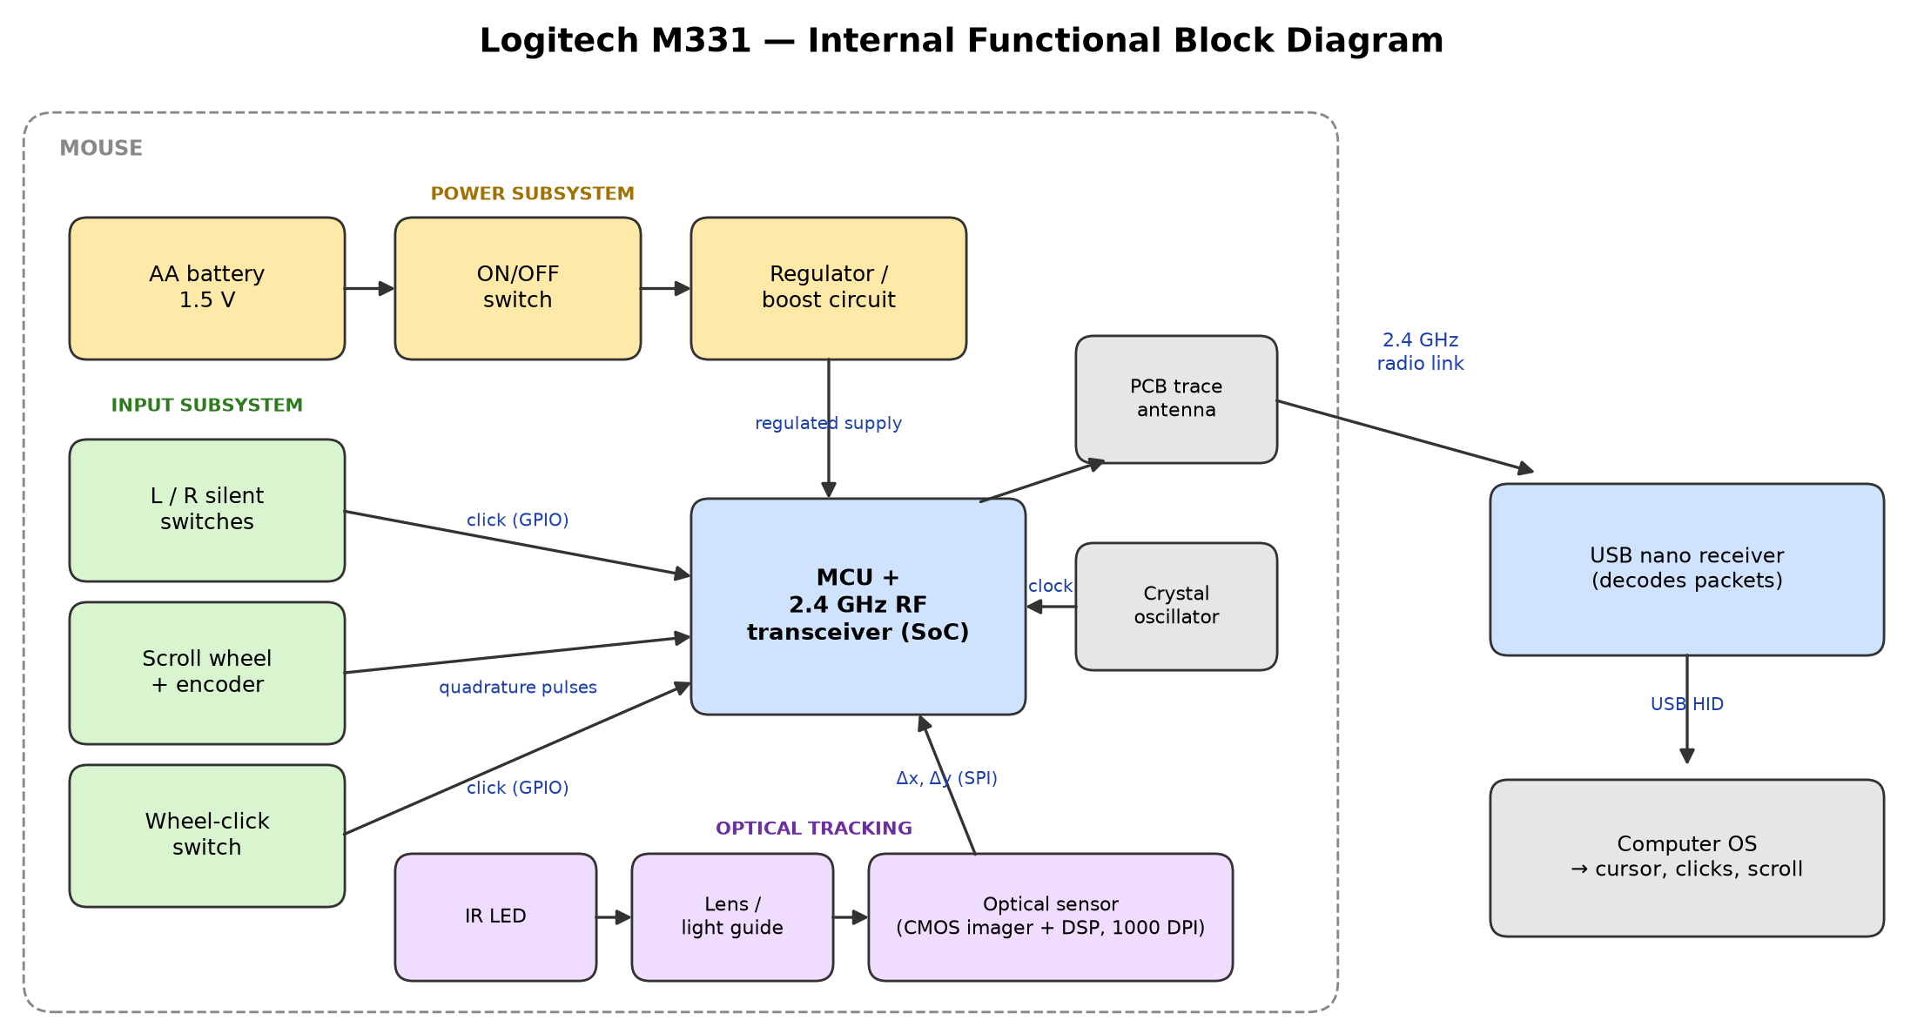
Fig. 3 – Functional block diagram of the M331.

4. Internal Subsystems with Detailed Explanation

4.A Power subsystem (AA battery, ON/OFF switch, contacts/spring, regulator/boost circuit)
4.1 Function (why it is used): Supplies stable electrical power to all electronics.
4.2 Working principle: The 1.5 V AA cell connects through spring contacts and the slide switch; a regulator/boost circuit converts it to the steady voltage the chips need.
4.3 Characteristics: Single AA cell; up to 18 months battery life (Logitech spec); auto-sleep reduces consumption.
4.4 Role in this product: Without it nothing works; the efficient design is why the mouse runs for over a year on one battery.

4.B Optical tracking subsystem (IR LED, lens/light guide, optical sensor)
4.1 Function (why it is used): Detects the movement of the mouse across the desk.
4.2 Working principle: The LED lights the desk surface with invisible infrared light; the lens focuses the surface texture onto a tiny CMOS image sensor that takes thousands of pictures per second. Its built-in DSP compares consecutive images to compute the shift Δx, Δy.
4.3 Characteristics: Optical, 1000 DPI; no moving parts; works on most non-glass surfaces.
4.4 Role in this product: Converts physical hand motion into cursor motion — the core function of a mouse.

4.C Input subsystem (L/R silent switches, wheel-click switch, scroll wheel + encoder)
4.1 Function (why it is used): Captures clicks and scrolling.
4.2 Working principle: Pressing a button closes a switch (a digital 0/1 signal to the MCU). Turning the wheel rotates an encoder that produces two offset pulse trains (quadrature); the order of the pulses tells the direction of scroll.
4.3 Characteristics: Silent switches cut click noise by over 90% (Logitech spec); rubber wheel with notched feel.
4.4 Role in this product: Lets the user select, open menus and scroll.

4.D Processing & wireless subsystem (MCU + 2.4 GHz RF SoC, crystal oscillator, PCB antenna, USB receiver)
4.1 Function (why it is used): Combines all inputs and sends them to the computer.
4.2 Working principle: The microcontroller reads the sensor (over SPI) and the switches/encoder, debounces clicks, packs the data into a report and transmits it by 2.4 GHz radio through the zig-zag PCB antenna. The crystal provides the precise clock frequency the radio needs. The USB receiver decodes the packets and presents them to the computer as a standard HID mouse.
4.3 Characteristics: 2.4 GHz digital radio; range up to 10 m (Logitech spec); plug-and-play (no driver).
4.4 Role in this product: The 'brain' and the wireless link of the product.

4.E Mechanical / enclosure subsystem (top button cover, upper shell with rubber grips, base with battery tube, battery door, snap hooks, 2 screws, feet)
4.1 Function (why it is used): Holds and protects all parts and gives the ergonomic shape.
4.2 Working principle: Moulded plastic parts clip together with snap hooks; only one case screw (under the label in the battery well) and one PCB screw are used. Button flaps press the switches below them; low-friction feet let the mouse glide.
4.3 Characteristics: ABS plastic housing, rubber side grips, ~106 × 68 × 39 mm.
4.4 Role in this product: Determines comfort, durability and ease of assembly/repair.

5. Complete Working Flow (Step-by-Step)
Step 1: User slides the ON/OFF switch to ON → battery powers the regulator → MCU, radio and sensor start; the mouse links to its USB receiver.
Step 2: The IR LED lights the desk surface; the lens focuses the surface image onto the optical sensor.
Step 3: The sensor captures images thousands of times per second; its DSP compares consecutive images and calculates movement Δx, Δy.
Step 4: The MCU reads Δx, Δy from the sensor (SPI) and checks the switches and the wheel encoder.
Step 5: When a button is pressed, its switch closes; the MCU debounces it and records a click.
Step 6: When the wheel turns, the encoder's quadrature pulses tell the MCU the scroll amount and direction.
Step 7: The MCU packs movement, buttons and scroll into a data packet and sends it by 2.4 GHz radio through the PCB antenna (timed by the crystal oscillator).
Step 8: The USB nano receiver decodes the packet and sends it to the computer as a standard USB HID report.
Step 9: The operating system moves the cursor, performs clicks or scrolls the page.
Step 10: If the mouse is not used, it enters a low-power sleep mode to save battery, and wakes on movement or click.

6. Components List – Bill of Materials
No. | Component | Qty | Material / Type
1 | Top button cover (L/R buttons, wheel slot) | 1 | ABS plastic
2 | Upper shell with side grips | 1 | ABS + rubber
3 | Base / bottom case with battery tube | 1 | ABS plastic
4 | Battery door | 1 | ABS plastic
5 | Scroll wheel (rubber tyre) | 1 | Plastic hub + rubber
6 | Wheel encoder | 1 | Rotary encoder
7 | Main PCB | 1 | FR-4 fibreglass, copper traces
8 | Silent tactile switches (L, R) | 2 | Damped tactile switch
9 | Wheel-click switch | 1 | Tactile switch
10 | MCU + 2.4 GHz RF transceiver | 1 | SoC IC
11 | Crystal oscillator | 1 | Quartz crystal (metal can)
12 | PCB trace antenna | 1 | Copper trace on PCB
13 | Optical sensor | 1 | CMOS image sensor + DSP IC
14 | IR LED | 1 | Infrared LED
15 | Lens / light guide | 1 | Clear plastic (polycarbonate/acrylic)
16 | ON/OFF slide switch | 1 | Slide switch
17 | Battery contacts + spring | 1 | Spring steel, plated
18 | Small sub-board with wires | 1 | PCB + wires
19 | Screws | 2 | Steel, Phillips head
20 | Feet (skates) | set | Low-friction pads
21 | Label sticker | 1 | Paper/plastic label
22 | USB nano receiver | 1 | USB dongle with RF chip
23 | AA battery | 1 | 1.5 V alkaline

7. Component Ratings & Specifications
Item | Rating / Specification | Source
Battery | 1 × AA, 1.5 V; up to 18 months life | Logitech
Wireless | 2.4 GHz via USB receiver; range up to 10 m | Logitech
Click noise | Over 90% reduction vs standard clicks | Logitech
Sensor | Optical, invisible light, 1000 DPI | Product review (Techspin)
Size | ~106 × 68 × 39 mm | Product review (Techspin)
Compatibility | Windows, macOS, Linux (USB HID) | Logitech
Crystal frequency | Read the marking on the metal can | To be measured
Switch life / IC part numbers | Not published — read chip markings | To be measured

8. Component Function Table
Component Name | Function | Specifications
Optical sensor | Images the surface, computes Δx/Δy | 1000 DPI, CMOS + DSP
IR LED + lens | Illuminates and focuses the surface | Infrared (invisible)
MCU + RF SoC | Reads inputs, builds and transmits reports | 2.4 GHz, low power
Crystal oscillator | Precise clock for MCU/radio | Quartz (value on can)
PCB antenna | Radiates the 2.4 GHz signal | Copper trace
L/R silent switches | Register left/right clicks quietly | >90% quieter clicks
Scroll wheel + encoder | Scrolling with direction sensing | Rubber wheel, quadrature
Wheel-click switch | Middle click | Tactile switch
AA battery | Power source | 1.5 V, up to 18 months
ON/OFF switch | Cuts power when not in use | Slide switch
USB nano receiver | Receives radio data, connects via USB | USB HID, 10 m range
Housing (shell, base, door) | Protection, ergonomics, assembly | ABS + rubber grips
Feet | Smooth gliding | Low-friction pads

9. Simulation of the Product's Working (Tinkercad Circuits)
The internal working of the M331 was simulated in Autodesk Tinkercad Circuits. Tinkercad has no optical sensor or 2.4 GHz radio, so the mouse's inputs are imitated with simple components and an Arduino Uno plays the role of the mouse's microcontroller. The Serial Monitor shows the movement/button report that the real mouse would transmit to the computer.
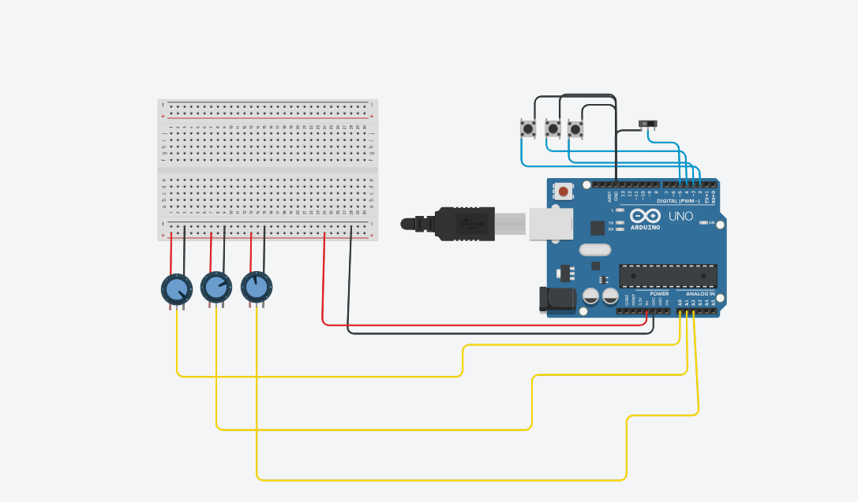
Fig. 4 – Tinkercad circuit: Arduino Uno (MCU), 3 potentiometers, 3 pushbuttons, slide switch, breadboard power rails.
M331 part | Simulated by | Arduino pin | Output in report
Optical sensor – X movement | Potentiometer 1 | A0 | dx
Optical sensor – Y movement | Potentiometer 2 | A1 | dy
Scroll wheel + encoder | Potentiometer 3 | A2 | scroll
Left silent switch | Pushbutton 1 | D2 | L
Right silent switch | Pushbutton 2 | D3 | R
Wheel-click switch | Pushbutton 3 | D4 | M
ON/OFF power switch | Slide switch | D5 | LED on / reports stop
MCU + radio link | Arduino Uno + Serial Monitor | — | REPORT lines

9.1 How the simulation works
- Power: Arduino 5V and GND feed the breadboard rails, which power the potentiometers (stands in for the AA battery and regulator).
- Movement: each potentiometer is a voltage divider; analogRead() converts its wiper voltage to 0–1023. The code reports the change since the last reading (dx = (x – lastX)/8), just as the optical sensor reports change in position. Dividing by 8 ignores small noise.
- Buttons and switch: pins use INPUT_PULLUP, so they read HIGH normally and LOW when the button/switch connects them to GND — no external resistors needed.
- Main loop: about 20 times per second the code checks the power switch (OFF → LED off, nothing sent = sleep), reads all inputs and, if anything changed, prints one report line — the same read → pack → send cycle the M331's chip performs.

9.2 Results
Sliding the switch ON lit the Arduino's L LED and enabled reports; turning the knobs produced dx, dy and scroll values; pressing each button produced L=1, R=1 or M=1; switching OFF stopped all reports. The simulation therefore reproduces the mouse's input → processing → report flow.
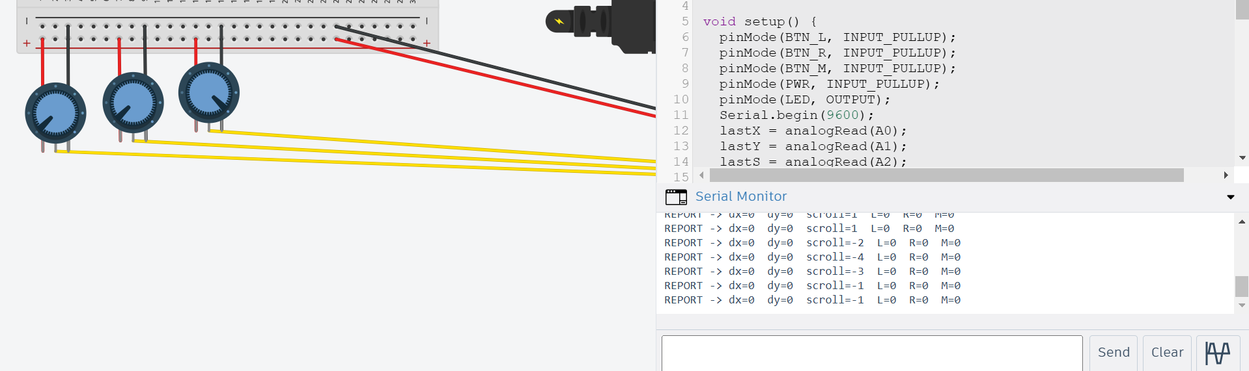
Fig. 5 – Serial Monitor: scroll values while turning potentiometer 3.
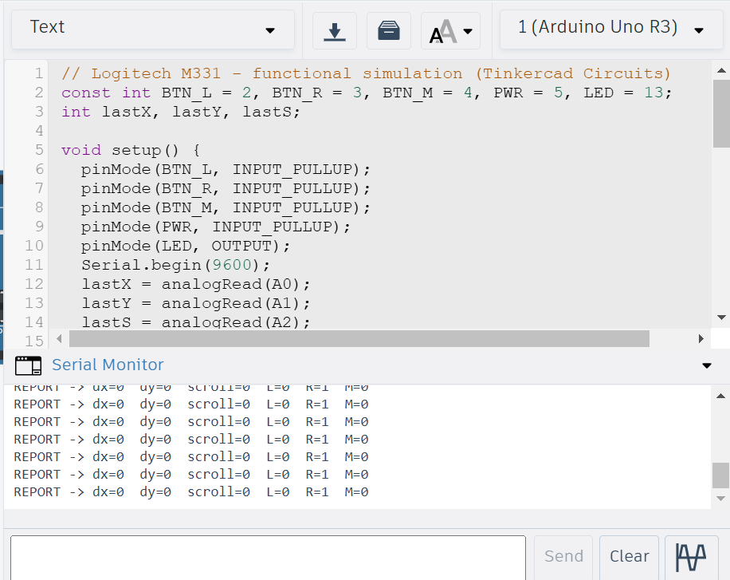
Fig. 6 – Code (Text view) and Serial Monitor showing R=1 while the right button is held.

9.3 Program code
// Logitech M331 - functional simulation (Tinkercad Circuits)
const int BTN_L = 2, BTN_R = 3, BTN_M = 4, PWR = 5, LED = 13;
int lastX, lastY, lastS;
void setup() {
pinMode(BTN_L, INPUT_PULLUP);
pinMode(BTN_R, INPUT_PULLUP);
pinMode(BTN_M, INPUT_PULLUP);
pinMode(PWR, INPUT_PULLUP);
pinMode(LED, OUTPUT);
Serial.begin(9600);
lastX = analogRead(A0);
lastY = analogRead(A1);
lastS = analogRead(A2);
Serial.println("M331 simulation ready - slide switch ON to start");
}
void loop() {
if (digitalRead(PWR) == HIGH) { // switch OFF
digitalWrite(LED, LOW);
delay(200);
return;
}
digitalWrite(LED, HIGH); // switch ON
int x = analogRead(A0), y = analogRead(A1), s = analogRead(A2);
int dx = (x - lastX) / 8;
int dy = (y - lastY) / 8;
int scroll = (s - lastS) / 64;
if (dx != 0) lastX = x;
if (dy != 0) lastY = y;
if (scroll != 0) lastS = s;
bool L = digitalRead(BTN_L) == LOW;
bool R = digitalRead(BTN_R) == LOW;
bool M = digitalRead(BTN_M) == LOW;
if (dx || dy || scroll || L || R || M) {
Serial.print("REPORT -> dx="); Serial.print(dx);
Serial.print(" dy="); Serial.print(dy);
Serial.print(" scroll="); Serial.print(scroll);
Serial.print(" L="); Serial.print(L);
Serial.print(" R="); Serial.print(R);
Serial.print(" M="); Serial.println(M);
}
delay(50);
}
Sources: Tinkercad Circuits (Autodesk); Logitech M330/M331 product page; iFixit 'Logitech M331 Disassembly'; Techspin M330/M331 review; general history of the computer mouse.

